**CASE STUDY - 6**

**Create following tables in SQL Schema with appropriate class and write the unit test case for the Ecommerce application.**

**Schema Design:**

1. customers table:

• customer_id (Primary Key)

• name

• email

• password

2. products table:

• product_id (Primary Key)

• name • price

• description

• stockQuantity

3. cart table:

• cart_id (Primary Key)

• customer_id (Foreign Key)

• product_id (Foreign Key)

• quantity

4. orders table:

• order_id (Primary Key)

• customer_id (Foreign Key)

• order_date

• total_price • shipping_address

5. order_items table (to store order details):

• order_item_id (Primary Key)

• order_id (Foreign Key)

• product_id (Foreign Key)

• quantity

1. **create table customers(**

**customer_id int primary key,**

**name varchar(225),**

**email varchar(225),**

**password varchar(225));**

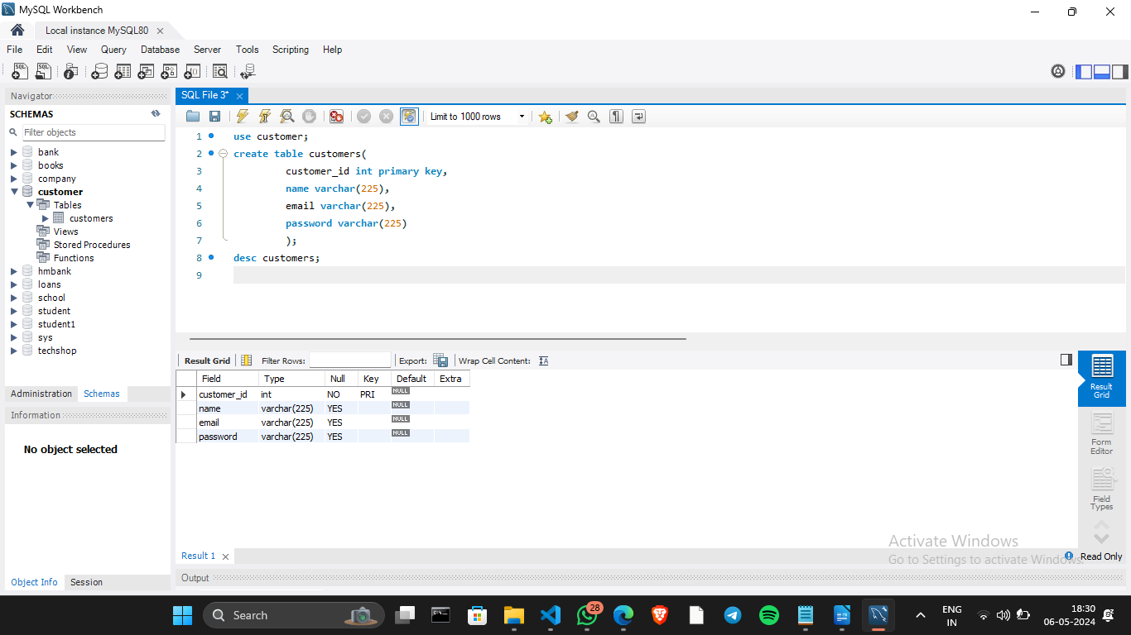

1. **create table products (**

**product_id int primary key,**

**name varchar(225),**

**price decimal(10,2),**

**description text,**

**stockQuantity int**

**);**

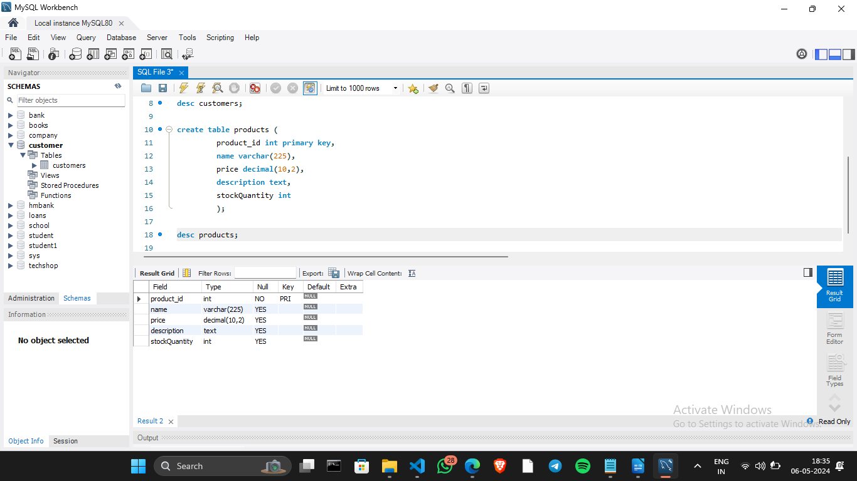

**3. create table cart(**

**cart_id int primary key,**

**customer_id int,**

**product_id int,**

**quantity int,**

**foreign key(customer_id) references customers(customer_id),**

**foreign key(product_id) references products(product_id) );**

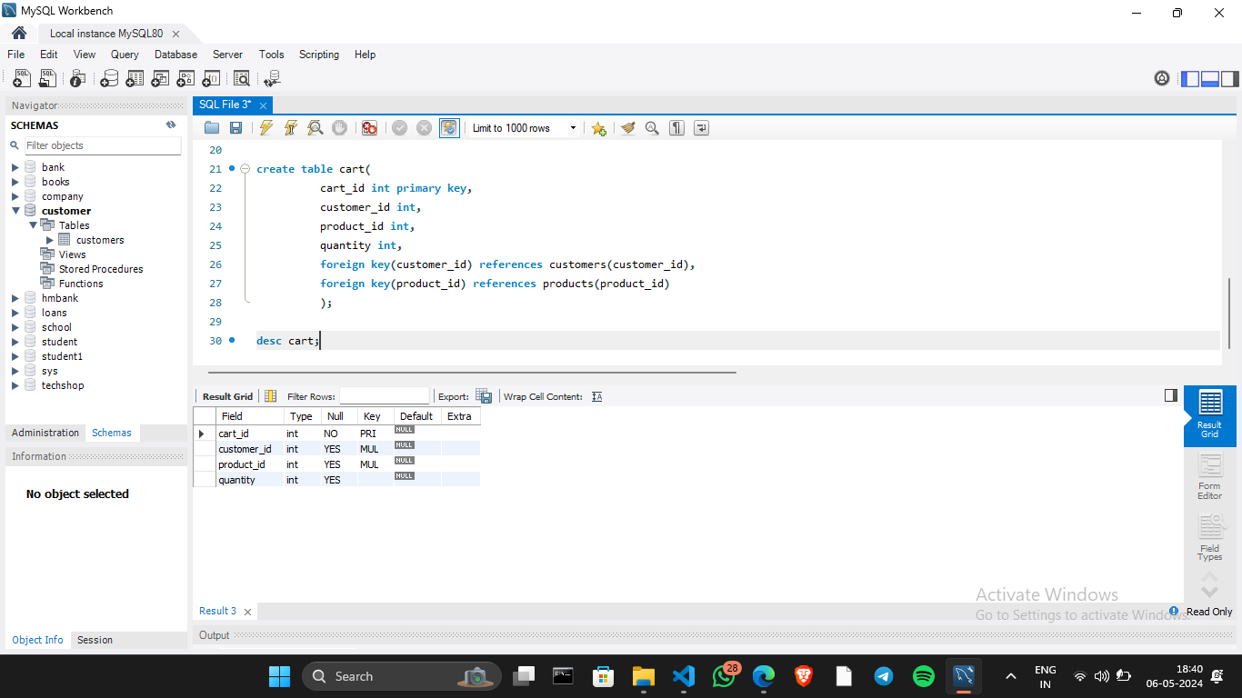

**4. create table orders(**

**order_id int primary key,**

**customer_id int,**

**order_date date,**

**total_price int,**

**shipping_address varchar(225),**

**foreign key (customer_id) references customers(customer_id)**

**);**

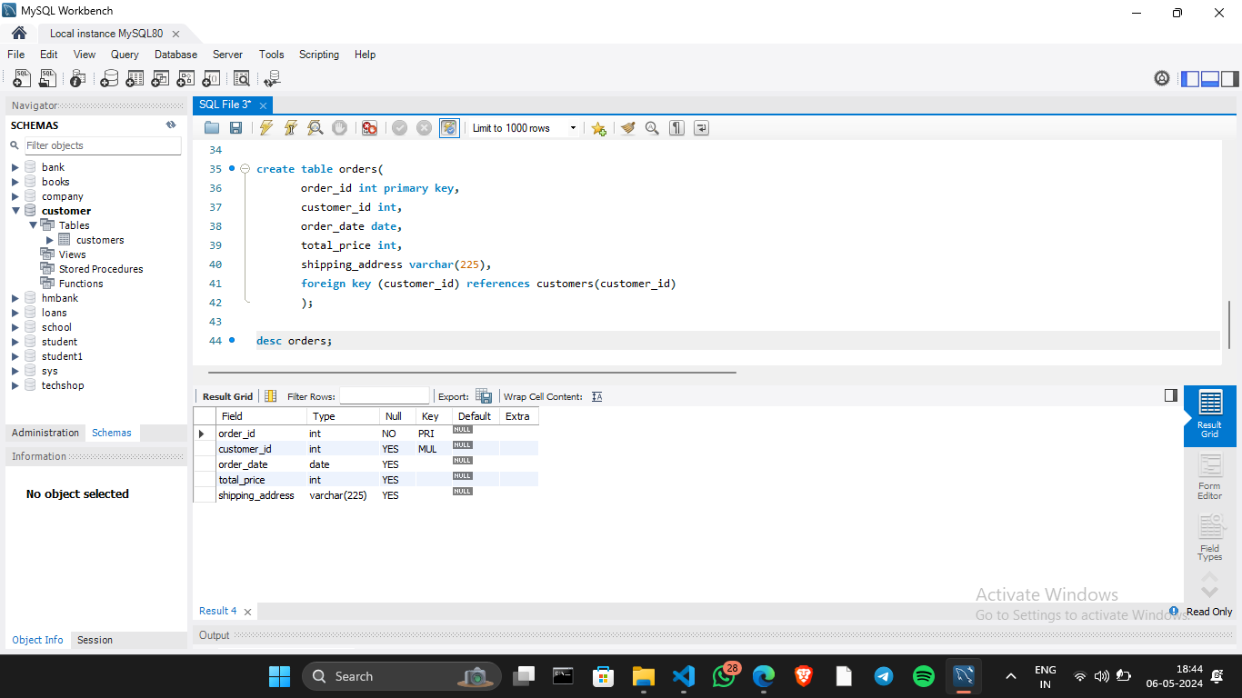

**5. create table order_items(**

**order_items_id int primary key,**

**order_id int,**

**product_id int,**

**quantity int,**

**foreign key(order_id) references orders(order_id),**

**foreign key ( product_id) references products(product_id)**

**);**

